标题：Signaling Targeting Cost Through List Price
作者及机构:
Peiwen Yu: School of Economics and Business Administration, Chongqing University, Chongqing 400044, China
Jiahua Zhang: Institute of Supply Chain Analytics, Dongbei University of Finance and Economics, Dalian 116025, China
摘要: Data analytics enable firms to offer personalized prices to targeted consumers but at a cost. We study a competitive personalized pricing game where the entrant is uncertain about the incumbent’s targeting cost. We demonstrate that implementing personalized pricing through a “list price-discount” scheme allows the incumbent to signal its targeting cost via the list price. This signaling mechanism is effective because the list price serves as a price ceiling, which limits the incumbent’s ability to extract consumer surplus through personalized discounts. The high-cost incumbent can strategically set its list price below the full-information level to separate itself from the low-cost incumbent. Interestingly, the high-cost incumbent prefers separating over pooling only when there is a moderate variation in the incumbents’ targeting costs. Personalized pricing can affect firms differently, benefiting the incumbent but hurting the entrant. Asymmetric information about targeting costs weakens the high-cost incumbent’s incentive to offer personalized discounts, resulting in lower total targeting costs and potentially increasing social surplus. These findings shed light on government regulations and transparency policies regarding personalized pricing.
AI标题: 标价信号机制破解定价博弈：高成本企业策略性标价抑制竞争
AI精炼: 该论文研究竞争环境下的个性化定价策略，探讨在位企业如何通过标价向竞争对手传递其目标成本信息，并分析信息不对称对市场福利的影响。现有文献多聚焦垄断或对称信息下的定价，而作者首次引入目标成本的私有性，构建博弈模型揭示标价作为信号的作用机制：在位企业通过“标价-折扣”方案将标价设为价格上限，高成本企业通过策略性压低标价（低于完全信息水平）与低成本对手分离，从而限制自身通过折扣抽取消费者剩余的能力。研究发现，标价信号的有效性依赖于成本差异的适中程度，且信息不对称会削弱在位企业使用个性化折扣的动机，降低总目标成本并可能提升社会总福利。这一机制挑战了“标价在个性化定价中失效”的传统认知，为实践中标价的广泛存在提供理论解释，也为政府监管与透明度政策提供新启示。
关键词:
信号机制
目标成本私有性
Hotelling模型
分离均衡
博弈模型
标价-折扣方案
社会福利效应
信息不对称博弈
学术要点: 学术要点 1：标价信号机制（List Price Signaling） 在位企业通过设定标价作为价格天花板，通过向下扭曲标价向竞争对手传递目标成本的私有信息，形成分离均衡的博弈策略。|||
学术要点 2：目标成本异质性（Targeting Cost Heterogeneity） 企业识别与触达消费者的综合成本差异，导致个性化定价能力的非对称性，影响市场竞争动态的非线性变化。|||
学术要点 3：信息不对称下的分离均衡（Separating Equilibrium under Asymmetric Information） 在位高成本类型通过设定低于完全信息水平的标价实现类型分离，其均衡存在性取决于目标成本差异的阈值条件。|||
学术要点 4：个性化定价的双刃效应（Dual Effects of Personalized Pricing） 在位企业通过剩余提取效应获益而进入者受损，形成竞争格局的再分配效应，同时增加消费者剩余但降低社会总剩余。|||
学术要点 5：社会福利的非单调性（Non-monotonic Social Welfare） 信息不对称通过降低目标成本投入与增加运输成本的双重路径，导致社会福利变化呈现倒U型特征，临界值由在位企业类型分布决定。
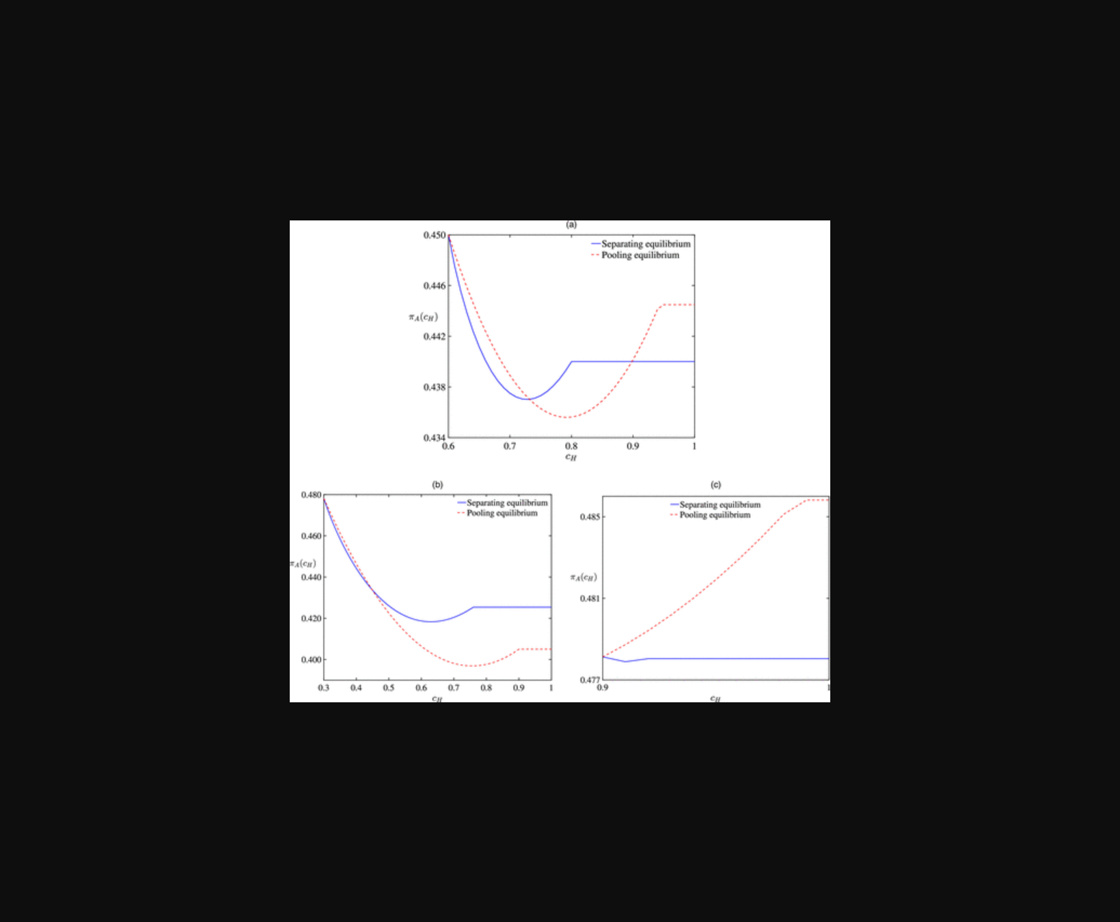
该图展示了不同目标成本下在位企业定价策略与市场均衡的动态关系。
原文链接: https://doi.org/10.1287/mnsc.2023.02031

